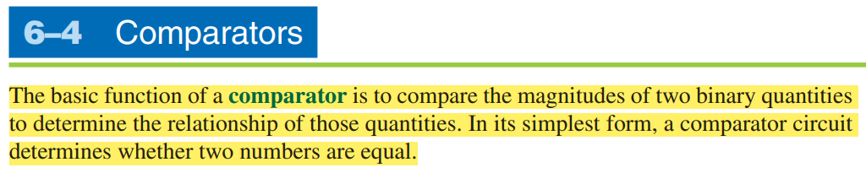

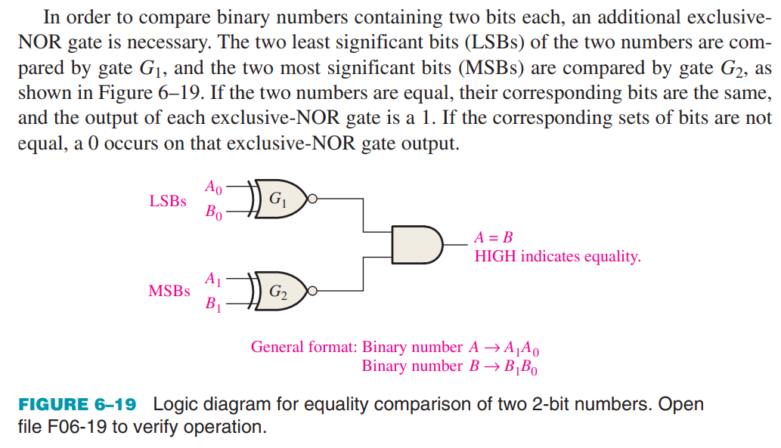

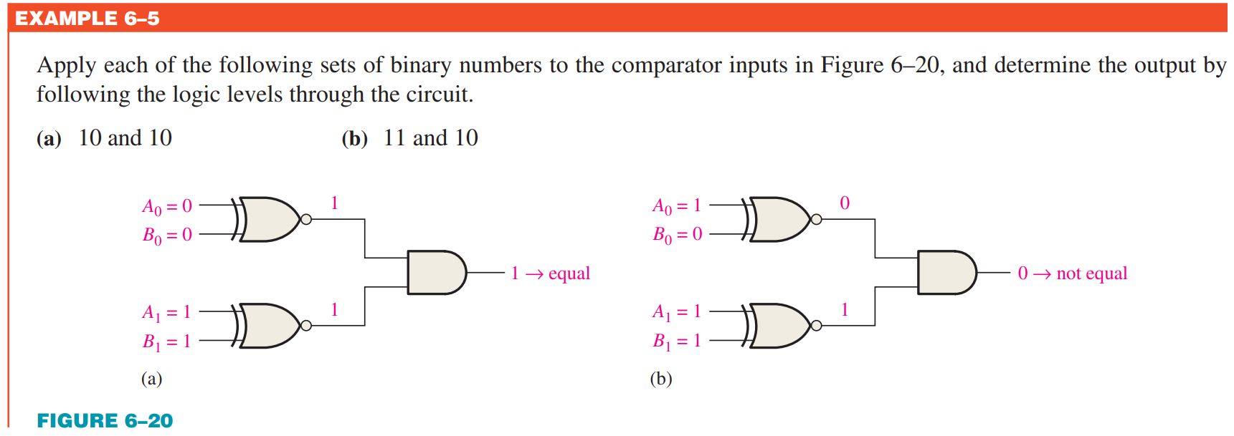

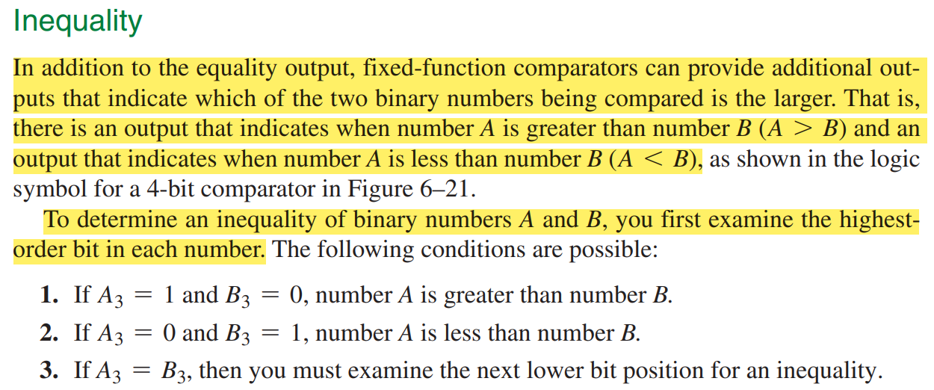

A comparator applied to compare two binary numbers with each of four bits is termed a 4-bit magnitude comparator. It consists of 8 inputs each for two four-bit numbers and three outputs to generate less than (<), equal to (=) and greater than(>) between two binary numbers.A diagram of a mathematical equation

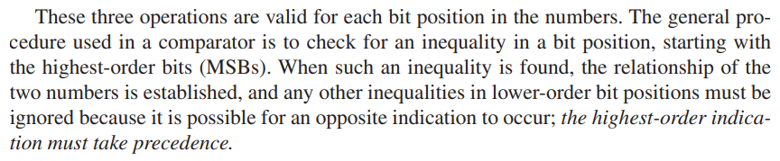

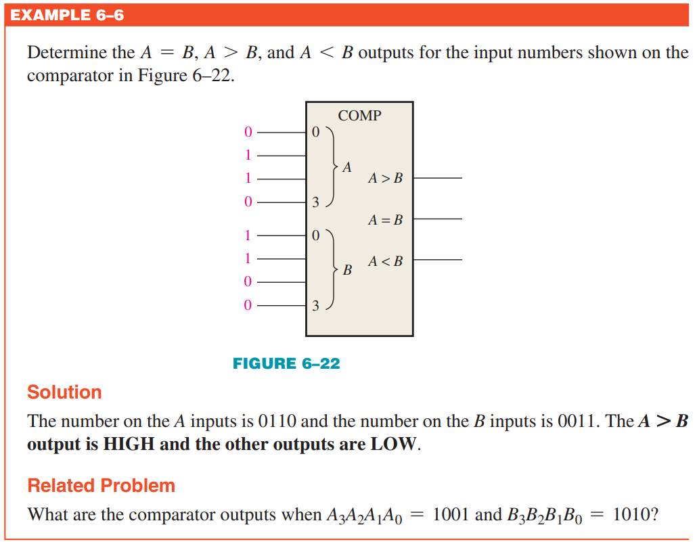

4-bit comparator

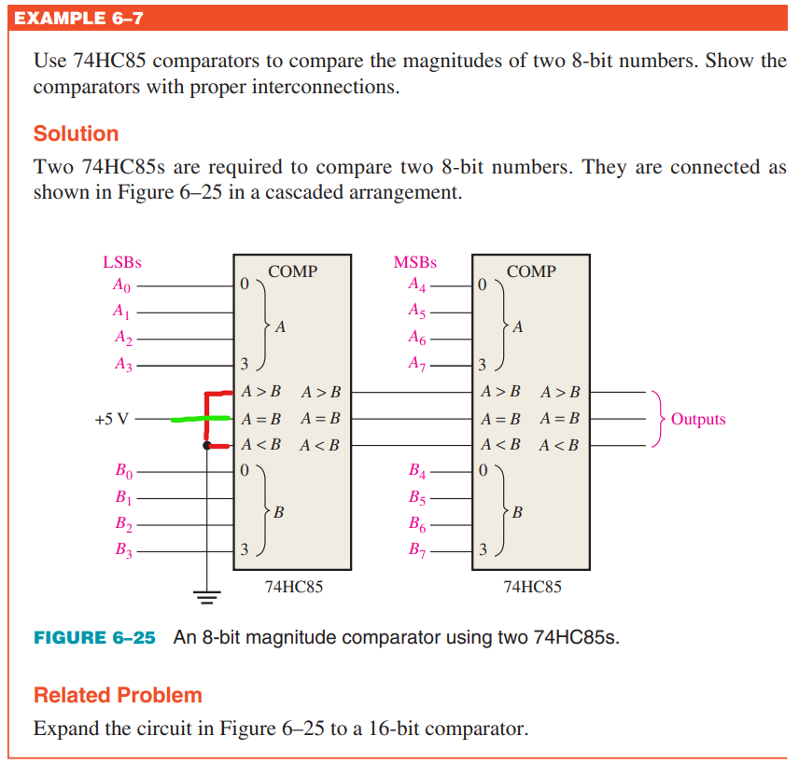

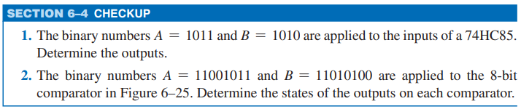

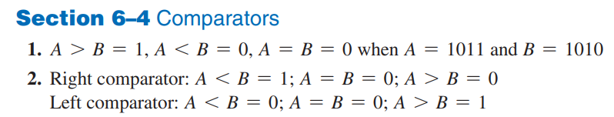

Left Comparator = LSBs

Right Comparator = MSBs